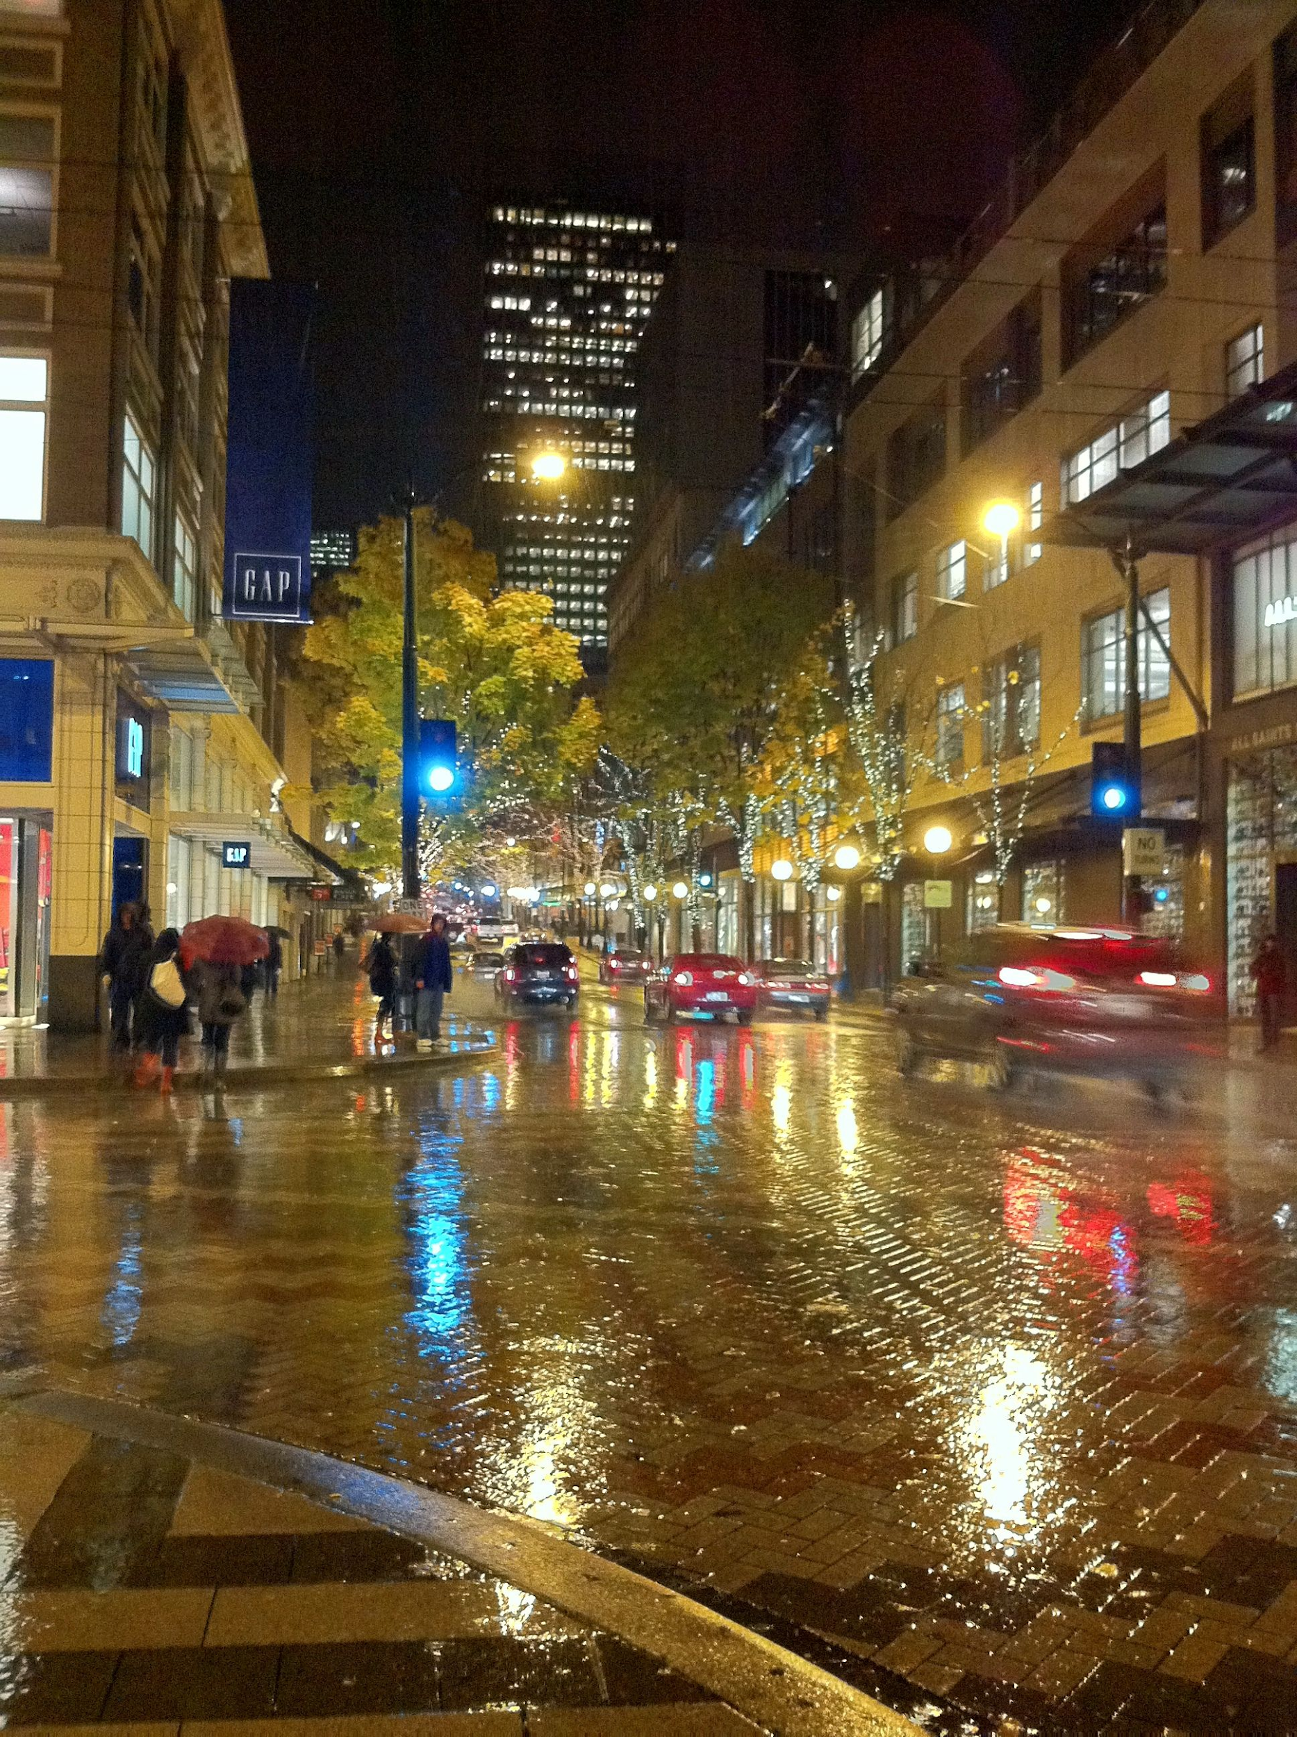

Safe Seattle Streets

Project Group Members: Osbert Lee, Yui Suzuki, Yukito Shida

# Summary of Research Questions and Results

1. **As the streets of Seattle become increasingly more dangerous with the addition of consistent protests and lootings, how can residents and students maintain their safety when traveling throughout the city streets?**
   1. Residents and students can maintain their safety when traveling throughout the city streets by using *Safe Seattle Streets*. By using this application, users can gain insight and awareness into what has been happening in their city. Accompanying the interactive visualizations, *Safe Seattle Streets* gives users the ability to use our machine learning models to make predictions about certain streets and timeframes - all backed up with our statistical analysis.
2. **How will the program determine what is a ‘dangerous street’ and how will the user view/interpret this information in order to cast judgement?**
   1. The program itself does not interpret what a ‘dangerous street’ is. In fact, the users will use the information *Safe Seattle Streets* provides in order to cast their own judgements. With all four interactive visualizations we will be able to display, as well as a prediction with an accuracy score, users themselves will be able to interpret the easily consumable data in order to make the best decisions possible when traversing the streets.
3. **Who is the target demographic and why would they need an application like this one?**
   1. Just in the past 24 hours, there have been approximately 300 fire calls to the Seattle Police Department. The target demographic falls under anyone currently in the Greater Seattle Area that wishes to increase their awareness of the dangers hidden in plain sight. The app primarily targets residents living in the area, however, can be used by all. Increasing awareness is important in deciding what route to walk on when going to work, or school. Given that the visualizations provided by *Seattle Safe Streets* include two different interactive plots that are measured by month, it is easy to ponder whether walking home is a safe, feasible option. Users safety is our goal and motive, and with this application, that will be achieved.

Motivation and Background

This project matters because of the impacts it could have on our community. With all of the lootings and riots occurring, Seattle has grown to be significantly less safe than it was in previous years. Everyday, on our own local news stations, we would hear about a hate crime or innocent people getting caught in the crossfire. All three of us were born and raised in the Greater Seattle Area and have been given so much by the communities we fostered. Hearing these horror stories that are happening right outside our front doors and seeing surveillance of different felonies on streets that we walked up and down to school really drives the heart of this project. Our motivations lie in the value that we wish to give back to the people that have given so much to us. With over 70% of all 911 calls relating to Medical Aid in Seattle, we at *Safe Seattle Streets* affirm that our project will bring awareness to potential threats in the area so that the innocent community that made us who we are today can stay as safe as possible.

With a dataset like this one that is live and updating every five minutes, we believe that it is very worth analyzing and creating plots for. By understanding that, in a given time frame, multiple 911 distress calls were made on a street that you use to traverse to work, you can plan accordingly and find a different route to maintain your safety. Although this project will not be able to stop the distress calls from happening, the product will create predictions for users to be aware of when casting their own judgements. This awareness can make a huge difference in what route is taken on the way home late from work. Seeing that a given street is predicted to have a 911 call at a designated time frame and finding a different route could potentially save an innocent life and stop a mugging/unlawful act.

# Dataset

The dataset we will be using to complete this project is the Seattle Real Time Fire 911 Calls data found in the URL below. The information that will be used in the dataset will be the address of the incident, the type of incident, and the datetime of its occurrence. Additionally, this dataset will update in real-time every five minutes, thus giving the most accurate interpretation possible.

For this project, we plan to have users access the dataset using the given API in the link below. This will allow users to not download the current dataset CSV file each time they want to run *Safe Seattle Streets*, and just use the online references instead. Additionally, since the dataset is live, the analysis for creating the graphics and the machine learning process will follow the routine of taking the current dataset when run and using that dataset until the program is relaunched. When relaunched, the dataset will have been refreshed to its newest state of the 911 calls and cast different judgements appropriately.

The application is intended to take all 1.5 million cases of 911 fire calls and only analyze the calls made in the last year. However, upon working with such a large dataset, we realized that we wouldn’t have the hardware to run and clean this entire dataset on any of our computers. Instead, we choose a random 2000 sample calls from the past two years to create our current visualizations and conclusions. If we had the proper hardware to tackle this issue, the dataset would’ve been cleaned to the point where only 911 fire calls made from the past 365 days would be used.

[Seattle Real Time Fire 911 Calls](https://data.seattle.gov/Public-Safety/Seattle-Real-Time-Fire-911-Calls/upug-ckch)

# 

# Methodology (algorithm or analysis)

**Description:** Our product, *Safe Seattle Streets*, should effectively be a program that takes in a given street and month to indicate how safe the street would be based on a 911 fire call dataset. The indications should be relayed through different graphics created based on the dataset. Specifically, the graphics should display plotted geographical maps of Seattle and given streets, and scatter and bar graphs that interpret the data on a wide spectrum across all types and months. These visuals give perspective on the relative danger of the street as well as broadening the perspective of those who don’t necessarily see these calls everyday. *Safe Seattle Streets* will also provide a prediction using machine learning to determine how likely a certain type of call would happen on a given street and month. We use two different models, Decision Tree Classifier and Random Forest Classifier, in order to determine our typing and make predictions for the user to interpret. The predictions would take in a street and month to compute the likelihood of a certain type of 911 call to occur. Finally, we used a statistical analysis to confirm the seasonal differences typically seen in the visualizations.

**Tie to Research Questions:** With the prediction and the visualizations, a user should be able to use their judgement to determine if they wish to wait another hour or take the risk. Thus, the target demographic (residents and students) will be able to utilize this information to maintain and improve their safety when traveling throughout the city streets in Seattle. All these judgements can be confirmed with the statistical analysis when looking at the numbers and graphs side by side.

Again, these visualizations, predictions, and statistical analysis will be an indicator of determining a ‘dangerous street’. A huge focus will be on the user to cast their own judgement on the situation as well. This application is not meant to determine what is safe and what isn’t, but rather to show off data trends and predictions that should be taken into consideration when a user feels unsafe walking on the streets of Seattle.

The target audience pertains to individuals that want to improve their awareness and safety in Seattle. Whether that be residents or students, *Safe Seattle Streets* will be an asset to those who wish to employ the application in their daily lives. Using the predictions and visual feedback to make safer judgements is crucial in protecting oneself and health. Thus proving why our target demographic would need an app like this one to enhance their quality of life in Seattle.

**Abstract level:** The problem is rooted in the domain of safety and improving QOL. The breakdown of the issue is as follows: Seattle 911 calls have increased by a noticeable margin in the past five years relative to what it was in the 2000s (Figure 1.0). What’s more is that an overwhelming majority of those dials are Aid Responses and Medical Responses (Figure 1.1). The question that comes to mind is ‘How can we improve Seattle’s overall safety in an environment that is growing more and more dangerous?’ Now that we have identified the back and problem statement, we can determine a course of action. Understanding that creating an application that stops robberies or employs measurements to decrease crime activity is unfeasible with our current abilities, we decided to turn towards fighting the issue from the back. *Safe Seattle Streets* will not stop crimes, but rather help individuals avoid getting caught in the crossfire. Our application will increase awareness of certain streets in Seattle that have seen lots of action in the past year. This way, users can use their own judgements to take/avoid risky walks down the street at given time frames. Therefore, we have successfully addressed the problem statement in an indirect fashion and hopefully increased the overall safety of Seattleites. In order to make this program a reality, we plan to use an algorithm to sift through a live feed of data provided by the Seattle Police Department to obtain and compile all the necessary information that a user would need to know. The stakeholders include Students, individuals that commute to work, and individuals that are not familiar with the greater Seattle area.

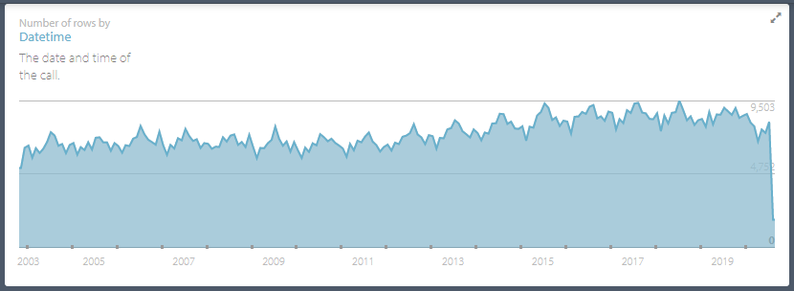  
(Figure 1.0)

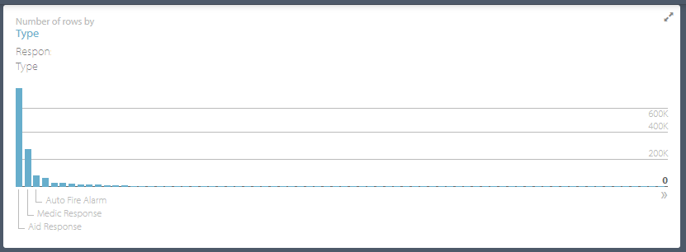  
(Figure 1.1)

# Results

**Description:**

We originally set out to create a program to visualize crime data around Seattle, where users can see clear trends based on multiple parameters. We also wanted to construct a machine learning model to predict the type of incident based on input time and place. However, we quickly ran into a difficulty. We realized we do not have the hardware and network capabilities that would allow us to parse through the entire dataset of 1.5 million from the API we decided to use. Attempts to do so resulted in our computers shutting down. This meant that we were forced to use less than 2000 random data points from the last two years from the API, which is obviously not representative of the overall dataset, especially when trying to plot points based on counting statistics such as the number of incidents or trying to train our machine learning model.

First, combat this, we decided to incorporate parameters which are not counting in our program. This included statistics such as proportions and categorical data such as the Month and incident type. These are the features we achieved in the program: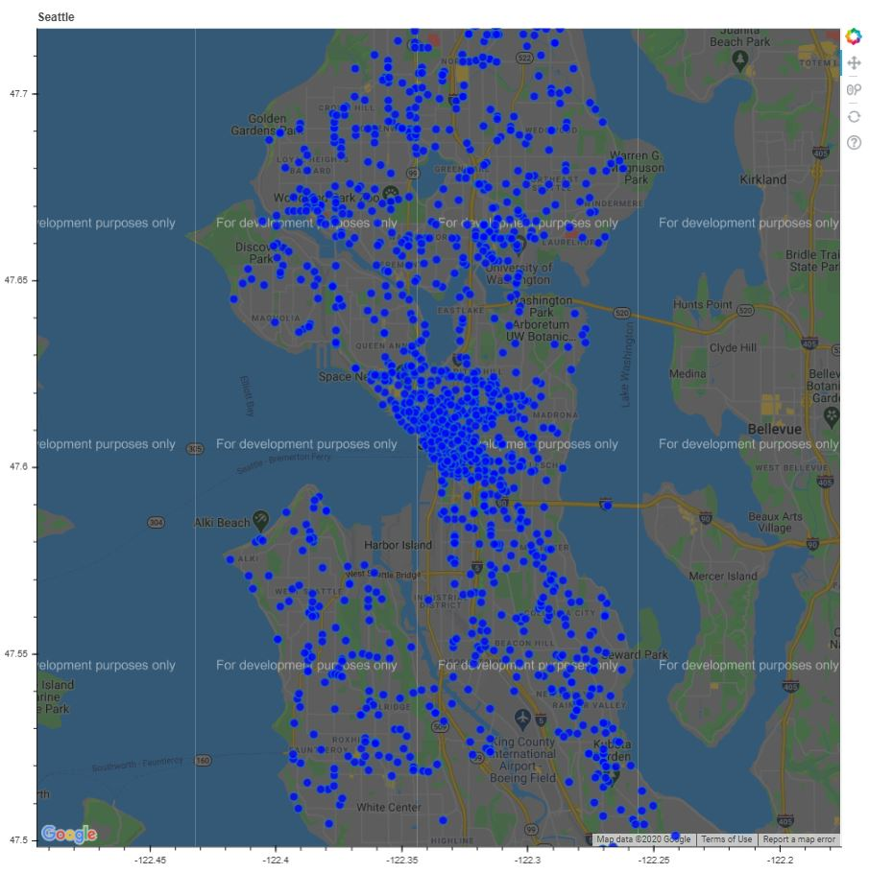

1. Incident overlays on Google Map. (Figure 1) is a plot of 2000 incidents over a map of Seattle. The actual map, opened as an HTML document, is interactive with zoom and scroll features. (Figure 2 and Figure 3) are zoomed in maps centered around 100 Ward St and 4120 Stone Way N respectively, where users have the ability to input street names within the program. Hypothetically, with stronger hardware, we would be able to parse through the entire dataset and query, for example, all of the incident reports from the previous 1 month, instead of using a sample of random data points. 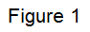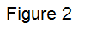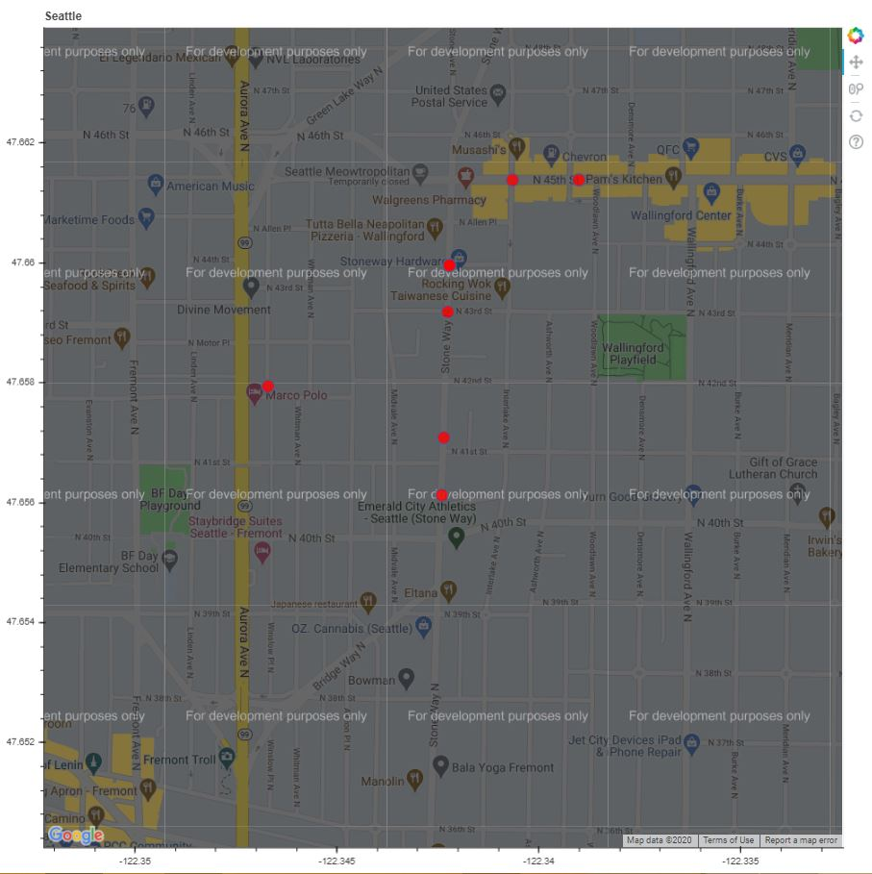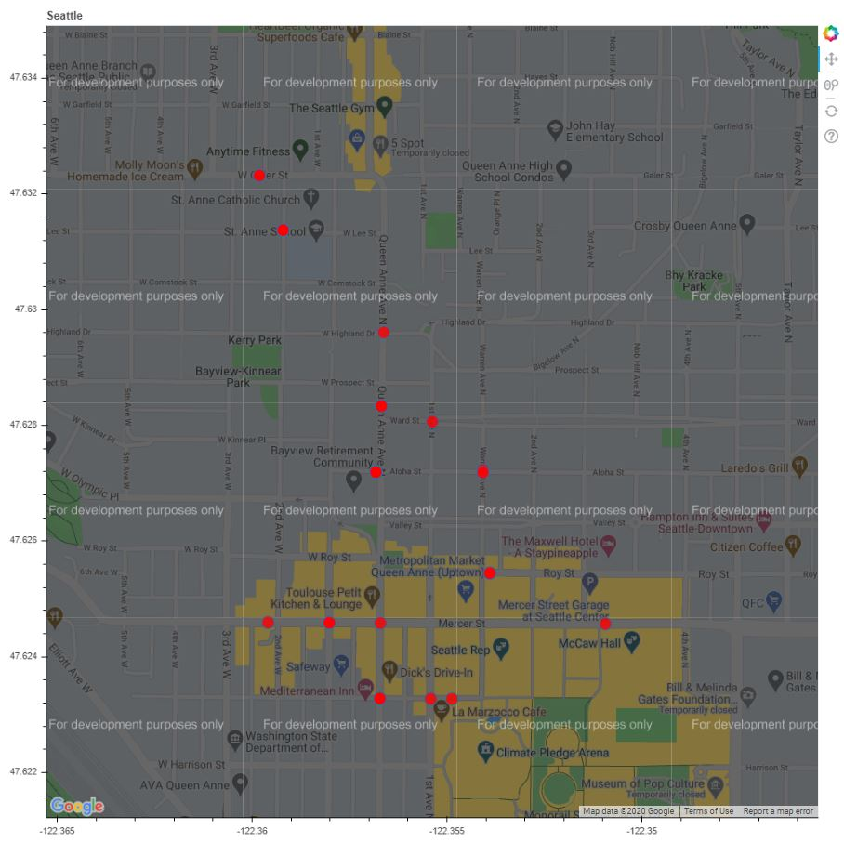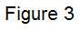

Lastly, all of the google maps are fully interactive, however has a grey overtone with “For developmental purposes only”. This is due to the fact that we would have needed to register with payment methods to google cloud services. Since we did not have a web domain to register our API key with, we felt that this would be adequate for this stage of our project.

1. Bar graph of the proportion of reports per each Month. In (Figure 4), we can see the proportion of cases that happen each month. The generated map is interactive with zooming and selecting capabilities.

We noticed here that the second half of the year seems to have significantly many more cases than the first half of the year. Since our goal was to provide our users with clear trends, we decided to calculate a confidence interval with “the proportion of cases that happen in Fall months are greater than the proportion of cases that happen in the Spring months” as our hypothesis. To make sure this calculation was done with proper measures for a simple random sample, we first divided our 2000 points of data into two randomly separated datasets. Doing this is technically cluster sampling, however, this was the best we could do to ensure independent samples with our given constraint and hardware. We then sampled that further by selecting 100 random data points from each of the two datasets we created. Those two 100 points of data are an approximately representative data of the entire dataset from the API. We then took the proportion of cases that were from each Spring and Fall seasons(March, April, May for Spring and September, October, November for Fall), and used the two proportions z-confidence interval algorithm to calculate our confidence interval. We used a confidence of 95% to calculate our interval. We also found through various trials that the each of n1p1, n1(1-p1), n2p2, and n1(1-p2), when n1,n2 = number of spring,fall cases, and p1,p2 = number of total cases for each dataset were all greater than 10, ensuring adequate sampling. As shown in (Figure 6) below, we can see that the algorithm calculated with 95% confidence that Fall months has a -1% to 13% higher proportion of 911 dials than Spring months. Although this is simply a range, **we can conclude statistically that in the last two years, Fall months tend to have higher incidence rates than during Spring months.** Since we use different sample data for each time we run the program, the confidence interval is expected to differ slightly each time it is run.

1. Plot of the number of cases of each type per Month. (Figure )5

This is a graph where we wished we were able to use the entire dataset. We wanted users to be able to see how different types of incidents, such as car fire and ambulance, differed throughout the year. This is a very interactive graph with great capabilities for users to see many trends. Users can select and deselect each report type using the selector on the legend on the right, and sort through whatever they want to see. Outliers are especially clear to see with this format and zoom/scroll capabilities help navigate through the data as well.

1. The user interface. We also created a user interface for the program as shown in (Figure 6) The user would call the program from a terminal, and input y/n based on whether they want to produce each graph or call a statistical analysis. For graphs and analysis that uses input data, the program will ask and utilize the input data as well. Finally, we would like to in the future create a full front-end for the user interface using HTML/CSS/JS because that is how a majority of our figures are produced.
2. Machine learning model to predict incident type based on given street and time. (Figure 7) We used two different classifier models, Decision Tree Classifier and Random Forest Classifier, in order to interpret the likelihood of a certain type of 911 dial’s occurrence in a given street and month. We chose this RFC model as our new model because it is a culmination of multiple decision tree classifiers and often yields a more accurate result. In this case, as shown in the figure, it yielded a result of ~42% accuracy. Unfortunately, a disadvantage of the RFC is that the data could overfit. Therefore, we wanted to compare and contrast the accuracy score of the DTC and the RFC. As a result, they were quite similar and typically had a difference of 0.5. The resulting accuracy displayed is the average between the two models used. With such a low accuracy score, our team pondered what could’ve been the cause of this and determined two possibilities. Because our data was a combination of 2000 calls in the past two years rather than all calls found in the same year, the variation could’ve caused a lower accuracy score. Another reason could be that it’s simply not possible to truly predict something so variable with great confidence; proving that these events and timeframes are all individual and do not have colliding effects on each other. We expected to see a stronger accuracy score with our machine learning models, but with these two hurdles in mind, the results cannot be solidified. Working with such a large dataset with so many different types of 911 dials, it’s difficult for the machine to understand because compared to the number of points we could assess and the number of types that exist, it’s not a fair assessment. In the future, we would like to use new libraries that could assess hundreds of thousands of data points for our machine learning model to predict off of.

Result Figures

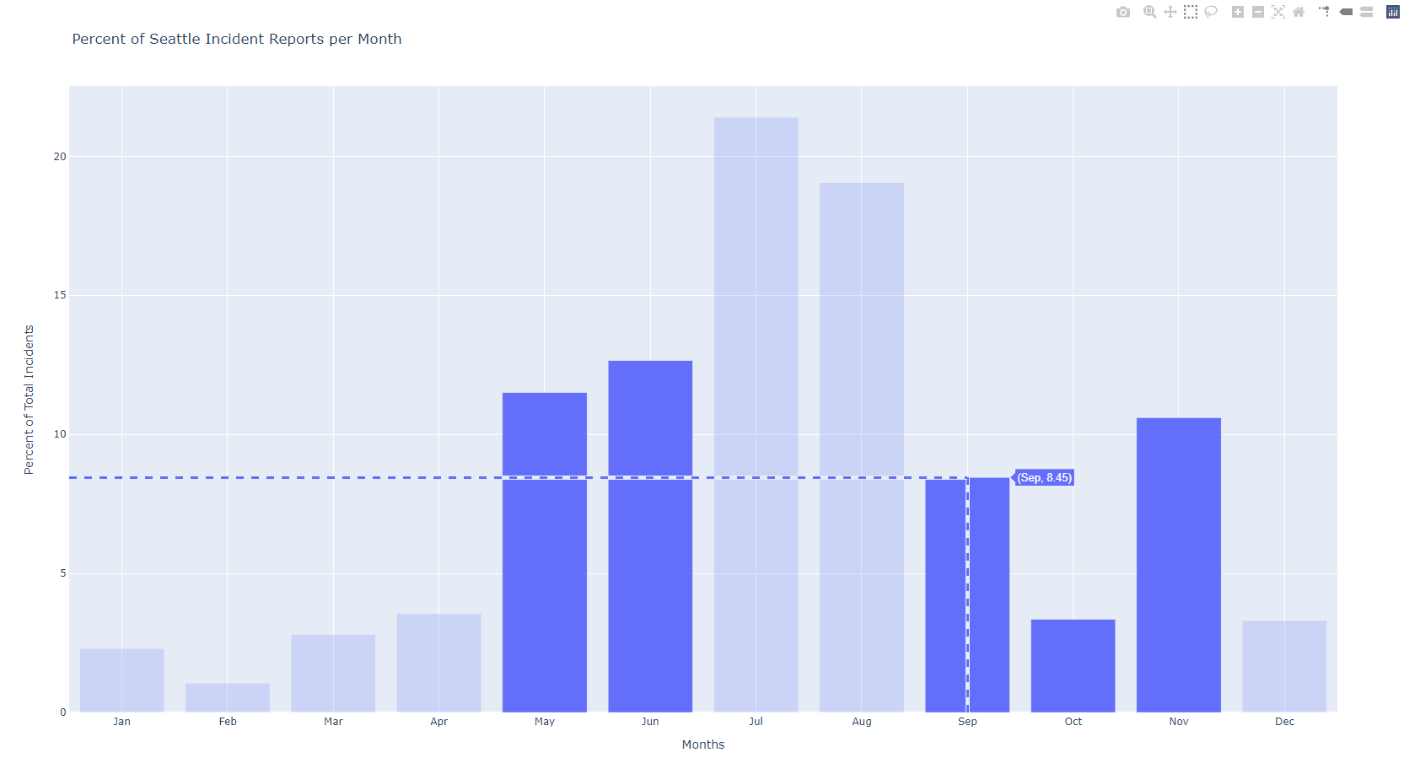  
(Figure 4)

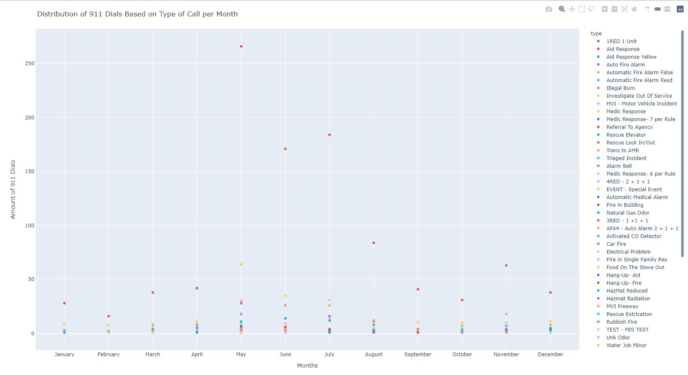

(Figure 5)

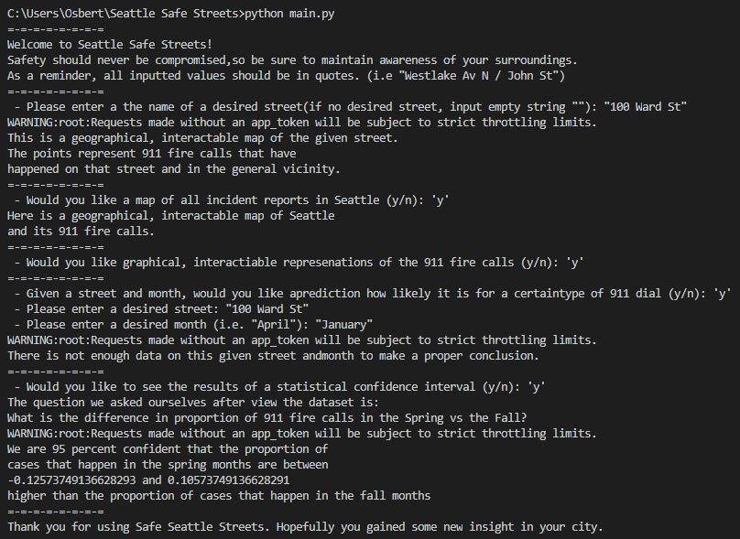

(Figure 6)

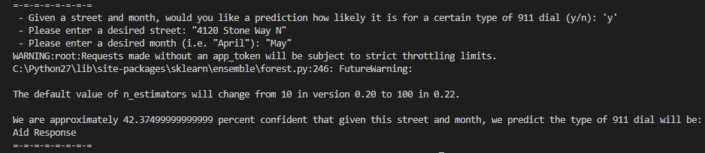

(Figure 7)

# Testing

* Here, we plotted on a bar graph, we graphed percentages by an increment of 5 each month, to make sure the bar graph code plots the data correctly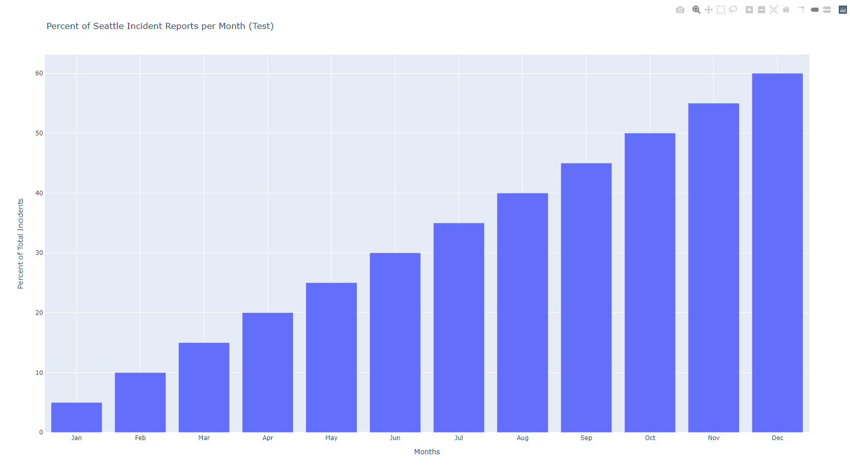.
* For the scatter plot, we used the dataframe as defined below to test our function.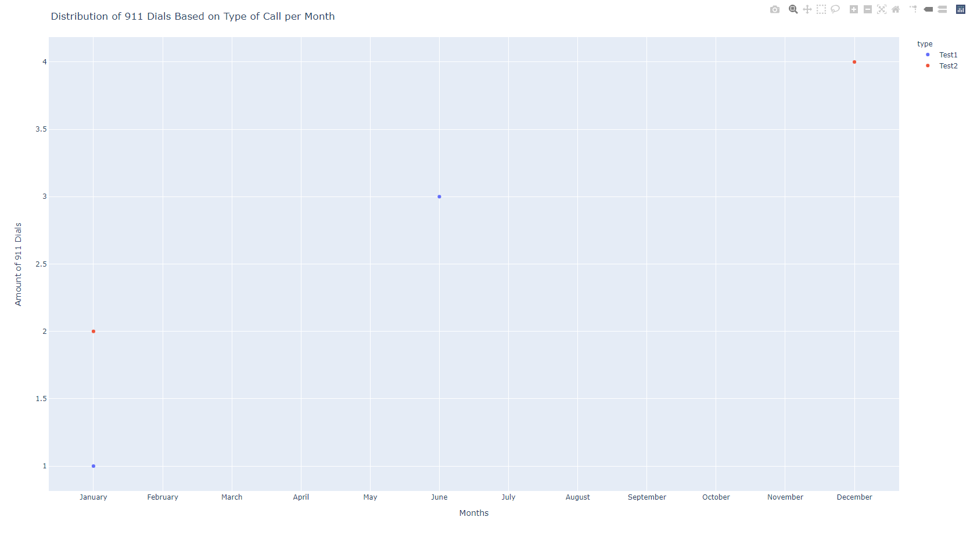

{'datetime': [1, 1, 6, 12], 'count': [1, 2, 3, 4], 'type': ["Test1", "Test2", "Test1", "Test2"]}

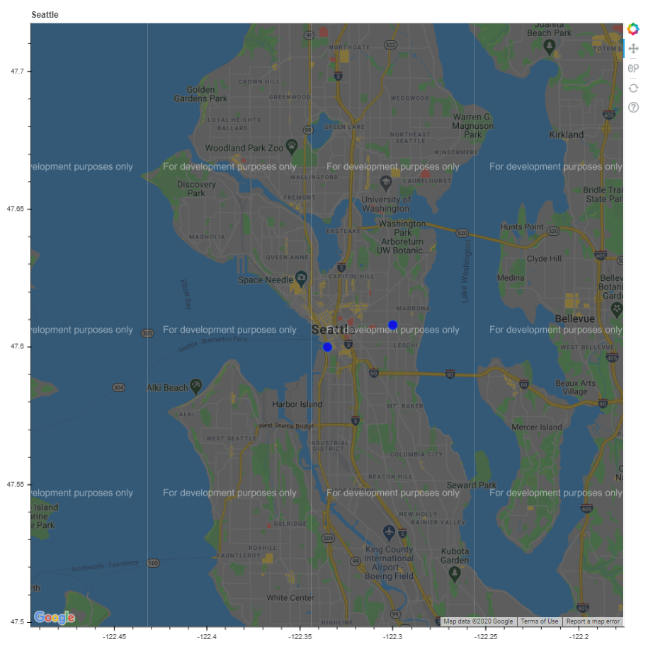

* For our maps, we put two points at (47.608013, -122.3) and (47.6, -122.335167) on the map to test it. Since the zoomed in code uses very similar code to the large Seattle map, and since we have produced numerous graphics shown in (Result Figure 2, 3), we have only provided the test for the overall map.
* For the confidence interval, we used several methods to make sure we used the correct methodology. First, we made sure that each of n1p1, n1(1-p1), n2p2, and n1(1-p2), when n1,n2 = number of spring,fall cases, and p1,p2 = number of total cases for each dataset were all greater than 10 and that the data collection measures followed simple random sampling as closely as possible. Finally, we calculated the confidence interval function at 90% confidence and the given parameters below. We used a TI-84 2-Proportion-ZTest to verify the results. The file containing this test named confidence_test.py is included in the file submissions.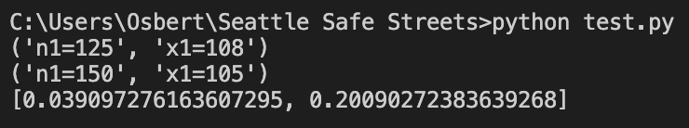
* For the machine learning aspect of our project, we used two separate classifiers to determine our final accuracy score. This was because, originally, we saw the disadvantages of using a Random Forest Classifier (overfitting the data). Therefore, for testing purposes, we created another model using the Decision Tree Classifier in order to see how different the results were side by side. The testing itself proved that there were minor differences between the accuracy scores provided in each classification. Afterwards, to ensure that our users can trust our data, we averaged the two accuracy scores together (typically with a 0.5 accuracy difference) to get a more accurate prediction.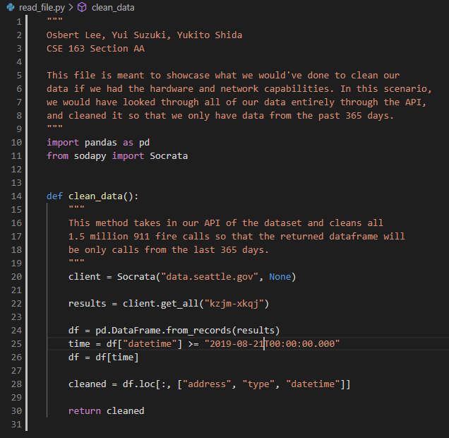
* Another part of testing that we did was we created a class called read_file.py. This file was meant to showcase what we would’ve done given a stronger hardware and network. The file itself is a simple function that shows the process of cleaning the data for the last 365 days (rather than 2000 random 911 calls from the past two years). This file is in the submission, but also photographed below.

# Collaboration

Collaboration wise, our team did not reach out to other students or people throughout the course of this project. However, we did use online resources to help us such as the plotly documentation, bokeh documentation, and different stack overflow problems that were similar to ours problems generated by learning these libraries. A major factor that we relied on was simple examples of how these libraries are used and implemented on youtube. These videos would give in depth explanations of how a library works and how it can be used. Some of these resources will be listed below.

<https://www.youtube.com/watch?v=2TR_6VaVSOs>

<https://www.youtube.com/watch?v=Mz1AXUE0nR4>

<https://www.youtube.com/watch?v=NhTRrnLHTTc>

<https://www.youtube.com/watch?v=XUNaGFa9xCM>

<https://www.youtube.com/watch?v=lb9QSP7NCd8>

<https://www.scipy.org/docs.html>

<https://pandas.pydata.org/docs/>

<https://docs.bokeh.org/en/latest/index.html>

<https://plotly.com/python/>

<https://pypi.org/project/sodapy/>

# Citations

Cover Photo: <https://www.pinterest.com/pin/175640454189530803/>

Both figures taken from: <https://data.seattle.gov/Public-Safety/Seattle-Real-Time-Fire-911-Calls/upug-ckch>